Working Paper: The Treatment of Debt in WACC Calculations in the Airline Industry: Evidence from Equity Research Analysts

Rob Langrick
CFA Institute

Michael Gorman & Bridget Lyons
Jack Welch College of Business & Technology, Sacred Heart University

Abstract
Estimation of a firm’s Weighted Average Cost of Capital (WACC) is essential for investment and capital structure decisions and is used to value firms under the Discounted Cash Flow (DCF) approach to valuation. The airline industry is capital intensive with most airlines relying heavily on debt and leases to finance aircraft. This paper explores various approaches to measuring the cost and amount of debt used when determining WACC. Of particular interest is the treatment of operating leases which are commonly used by airlines but historically have not been treated as debt by many accounting and finance professionals. We also examine the treatment of short-term debt and cash in WACC calculations. The paper includes a summary of existing literature, survey results of equity research analysts in the airline industry and details on the approach used by data providers including Bloomberg and FactSet. The results show surprising variation in the treatment of debt components which impacts the cost of capital estimates used in discounted cash flow valuation.

Introduction
The weighted average cost of capital (WACC), first proposed by Solomon (1955) and expanded by Modigliani and Miller (1958) is a firm’s current cost to raise capital to finance its assets. It is a function of the cost of raising debt, the cost of raising equity and the ratio of debt to equity, called the capital structure (for firms using preferred stock, this is included in the WACC). Despite the leaps and bounds the world of finance has taken over the intervening years our basic understanding has not changed substantially since that time.
Over time the specification of the model has been improved, Arditti (1973), criticism and redefining the model have been largely fought off, as seen in Nantell and Carlson (1975) leading to a stable understanding WACC over the better part of 70 years.
The WACC calculation is integral to determining firm valuation and making capital budgeting, leasing and capital structure decisions. While the WACC formula presented in most textbooks is simple, in practice the WACC calculation is made more difficult by several issues. Some of these issues have been researched in detail including what to use for the risk-free rate, how to estimate forward looking betas and how to determine the equity risk premium used in determining the cost of equity. Other issues have received far less attention including how to handle permanent levels of excess cash, whether to include operating leases as debt equivalents, whether and how to consider noncontrolling interests and how to incorporate the recent tax changes limiting the deductibility of interest expense.
In this paper we focus on determination of the amount and cost of debt to use in the WACC calculation.

Literature Review
Understanding the capital structure of the firm has long been a foundational topic in Finance. From the much-celebrated work of Modigliani and Miller (1958) laying the foundation for the field there have been numerous advances.
Branches of the literature have addressed conflicts of interest and agency problems, and the impact on the capital structure. Conveying private information to capital markets (approaches relying on asymmetric information) has also been explored and found to have impact on a firm’s capital structure. Further sectors of the literature have provided evidence to demonstrate that the nature of products and competition either in the input or output of the firm may impact capital structure, and also that the outcome of battles for corporate control can have an impact. A fairly comprehensive overview of the literature was provided by Harris and Raviv (1991) which retains relevance despite its age.
While each of these branches of the literature on capital structure have value, they generally focus on the choices that come together to determine capital structure, and pay less attention to the result of that capital structure and its impact on the business.
In introductory finance courses around the country using the most popular standard texts students are taught that the capital structure of the firm, a decision made far above most of the employees of the firm, will impact them through the weighted average cost of capital. That this number, or versions of it, will determine as an employee/agent the returns their business unit is expected to generate for the business, and the overall returns that investors therefore expect.
In Brigham and Houston, Fundamentals of Financial Management, now in their 16th edition (indicating some degree of popularity among institutions), the Weighted Average Cost of Capital is presented as being calculated by the following equation.
$$WACC=w_{d} r_{d} \left(1-T\right)+w_{p} r_{p}+w_{s} r_{s}$$
Where the weights (w) are calculated as the percentage of capital obtained through that instrument and the returns (r) represent the required returns of those investors. The instruments common stock (s), preferred stock (p) and debt (d) are represented by their respective subscript. T represents the corporate tax rate that the firm is subject to. The purpose of this equation is to highlight the impact of the tax deductibility of interest payments (as opposed to dividends or stock repurchases), and to demonstrate that preferred and common stock holders have different required rates of return.
This equation, with minor variation, is offered as standard in texts in introductory finance and specialized texts in corporate finance. It is sometimes the case that preferred stock is not considered for simplicity, and details of calculating the various components may offer some variability, but generally this is the version we present to students as the method used to calculate the investor expectations of firm returns.

Key Considerations in Estimating the Amount and Cost of Debt in WACC Calculations
Despite the ubiquitous use of WACC, there is not a clear consensus on how to actually determine the values used in the calculation. Yet selecting what to include as debt and how to measure the cost of debt significantly impacts the result.
Considerations include:
- Whether to include long-term debt only or both should short and long-term debt.
- The treatment of leases. Are leases debt? Which leases should be included as debt? Financial, operating, or both?
- The use of gross or total debt versus net debt where excess cash and equivalents is netted against the gross amount of debt.
- Estimation of the cost of debt: Average current cost of long-term debt? Or should it be the weighted average of the costs of all debt?
- If operating leases are treated as debt, how should the amount and cost be estimated?
For some firms these decisions have a very material impact. At 12/31/2024, United Airlines reported the following. We calculate the weight of debt in the capital structure in 4 ways. In this example, there is over a 120 basis point spread in the amount of debt across the approaches.
- Debt includes long-term debt and financial leases only, no operating leases.
- Debt includes both short- and long-term debt & financial leases, no operating leases.
- Debt includes short- and long-term debt and both financial and operating leases.
- Debt includes short- and long-term debt and all leases. Cash is netted against debt.

United Airlines 12/31/24
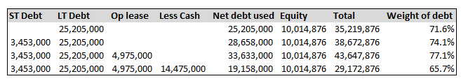

The Significance of WACC on Firm Valuation
Next we consider the impact on the firm’s valuation. A higher WACC leads to a lower valuation but the impact is influenced by the growth rate. For illustrative purposes we set up a simple example to demonstrate the importance of WACC for valuation.
We value a steady state firm using the constant growth approach. Assume free cash flow is estimated at $100.
If the growth rate is 2% and the WACC is 8% the value of the firm = $100 / (.08 - .02) = $1,666.7
The impact of different growth rates and WACC on the valuation is shown in the table below. For a firm with a growth rate of 3%, the estimated value is $2,000 if WACC is 8%. If the WACC is fifty basis points higher or lower the value is $1,818 (9% lower), or $2,222 (11% higher).
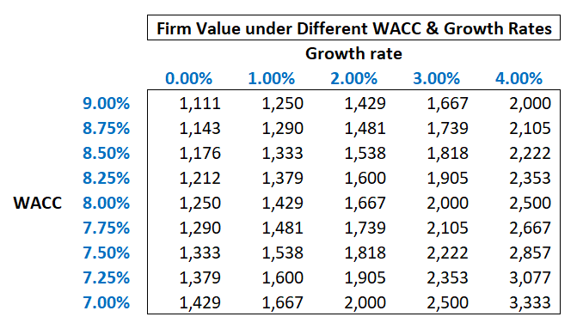

How Should Debt be Calculated for the WACC Estimates?
Short-Term Debt
There is no consensus on how to calculate debt for WACC. There is a general consensus that short-term debt should be included if short-term debt relates to the current portion of long-term debt or if the short-term debt is used to finance long-term assets. Debt to fund short-term working capital needs is typically not considered part of the capital structure. However when reviewing the financial statements it is not always clear if short-term debt is being used for only working capital needs.

Operating Leases
Historically debt and financial leases (on balance sheet) were included as debt in WACC calculations and operating leases (off balance sheet) were not considered debt for WACC calculations. Effective for 2020 and beyond, public firms, reporting under US Generally Accepted Accounting Principles (GAAP), are required to show operating lease liabilities and corresponding assets on the balance sheet. For firms reporting under International Financial Reporting Standards (IFRS), there is now a single lease accounting model; all leases are accounted for as financial leases and are shown on the balance sheet.
Note this is an acounting rather than economic change. There is no impact to cash flows since the new US GAAP and IFRS rules have no impact on the lease expense paid. However, firms reporting under IFRS will show all leases as debt while firms reporting under US GAAP will technically only show finance leases as debt. Historically, many credit analyts treated operating leases as debt and converted the leases to debt equivalents. However the operating leases were typically not treated as debt in WACC calculations.

The airline industry has historically used leasing heavily to manage their assets. Aircraft are commonly leased, as a means to increase access to usable assets without assuming the full risk of depreciation on the asset linked to the residual value. The lease pushes the depreciation risk onto the lessor and allows the lessee to fix the cost of depreciation up front.
European airlines operating under IFRS have consistently categorized operating leases as debt. US based airlines however have not historically had to list operating leases on the balance sheet, however as of the adoption of Accounting Standards Update ASU2016-02 Topic 842, firms are required to list Operating leases as a separate line item on the balance sheet, as both a liability and a right of use asset. As a result if we extract debt from the balance sheet and use the book value of debt to determine the weighting in the WACC we will exclude operating leases value from GAAP based accounting statements, and include them for IFRS based accounting statements.
It seems reasonable to argue that we must measure debt consistently across firms regardless of the accounting standard which suggests treating operating leases as debt.
One wrinkle to consider is whether the cost of operating leases is different from the cost of other debt. The notes to the financial statements include the discount rate used on operating and financial leases but this is a historic value set at commencement of the lease so the current cost of debt needs to be estimated. In any case the WACC calculation generally uses an estimate of the firms current cost of borrowing over the medium term.

Cash
It is unusual to see cash netted against debt in a WACC calculation. However for firms with permanent levels of excessive cash balances an argument can be made that this is indeed a capital structure decision. In such cases we believe that cash should be considered. Ignoring cash seems incorrect since holding large excess cash positions requires funding this investment with debt and equity and is therefore a capital structure decision. That said, using net debt is problematic since then the tax shield created by debt is inaccurate. Some analysts recommend a restatement of the WACC formula as shown below but this does not appear common practice among airline analysts.

Find Capital as Debt – Cash + Market value of Equity
WACC =Debt/Capital * rd* *(1 – tax rate) - Cash/Capital* Yield on Cash*(1-tax rate) + Equity/Capital * re

Survey and Results
To better understand how WACC is calculated by finance professionals, we surveyed 45 equity research analysts following airlines to see how they measured debt and estimated the cost of debt. We focused on airlines since operating leases are so common here. One analyst replied that he did not estimate WACC or use the DCF approach to valuation, relying instead on earnings multiples to value airlines. Seven airline analysts completed the survey. The results follow in Appendix1.

Determining the Amount of Debt
Regarding question 1, the analysts generally included short-term debt, long term debt and all leases as debt. The one analyst who did not include operating leases noted that he treated operating lease as an expense when doing a DCF valuation so did not include the lease in the WACC calculation. One of the analysts included unfunded pension obligations as a source of debt. The others did not but might include these obligations as adjustments when determining equity value based on a DCF valuation of the enterprise.
The results from question 2 show it is most common to value the operating lease using the balance sheet value. One analyst use a multiple of the lease expense. This treatment was a common way to estimate the value of operating leases prior to the change in accounting. It is sometimes also used to compare firms which use leases with different lives since the balance sheet value reflects the life of the lease. If Airline A typically uses 5 year leases but Airline B typically uses 10 year leases the balance sheet values may differ materially but the lease expense reported is likely to me much closer.

Question 4 examines the use of gross versus net debt. Here the respondents are split with three using total debt and 3 netting cash and equivalents against debt. For an airline with significant cash balances, like United Airlines, this decision materially impacts the result.

Determining the Cost of Debt
Question 3 looked at how the cost of debt was estimated. Four of the seven analysts estimated using a weighted average of the current yield to maturity on outstanding bonds and/or an estimate of the current cost of bank debt to the firm. One used the long run rate based on default risk.

This suggests some variation in how industry professionals determine the amount and cost of debt when estimating an airline’s WACC.

How Do the Data Providers Calculate WACC?
Some data providers include estimates of WACC. Perhaps the most widely used are Bloomberg and FactSet. We also look at FElix since the approach is different.
The results for Delta at February 21, 2025 follow.

Bloomberg
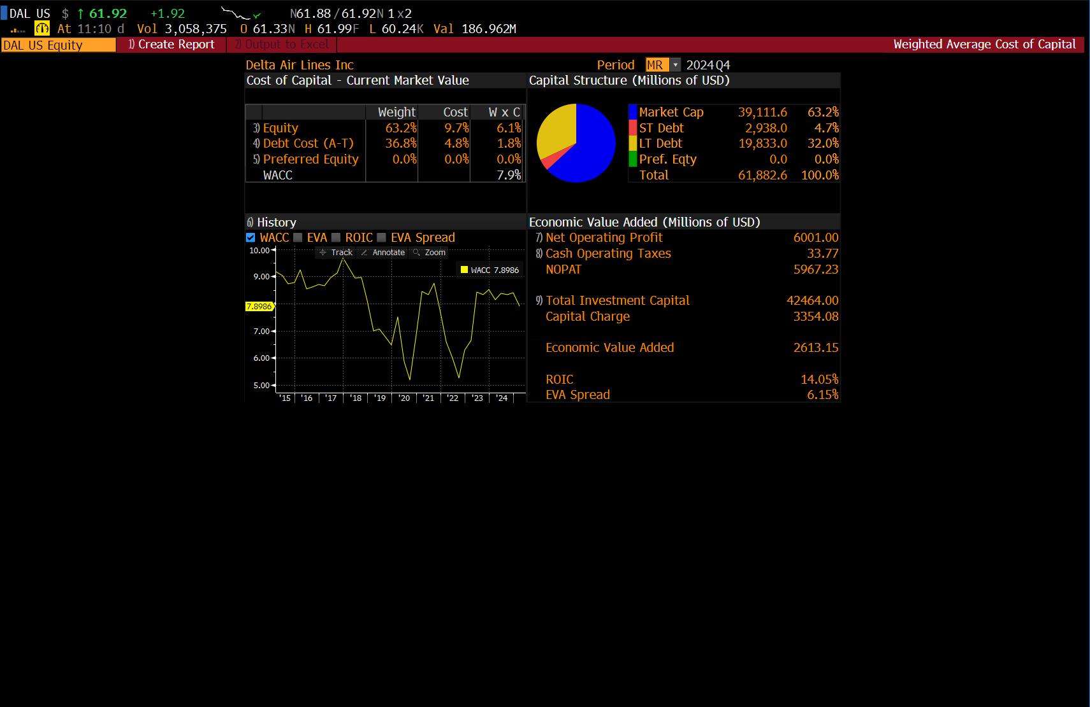

The FactSet estimate follows. FactSet does not include operating leases as debt in WACC calculations, instead treating operating leases as an operating expense.

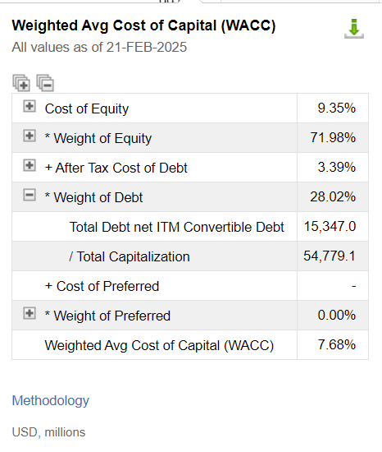

FElix offers a toggle to include or exclude operating leases. The WACC including operating leases follows.

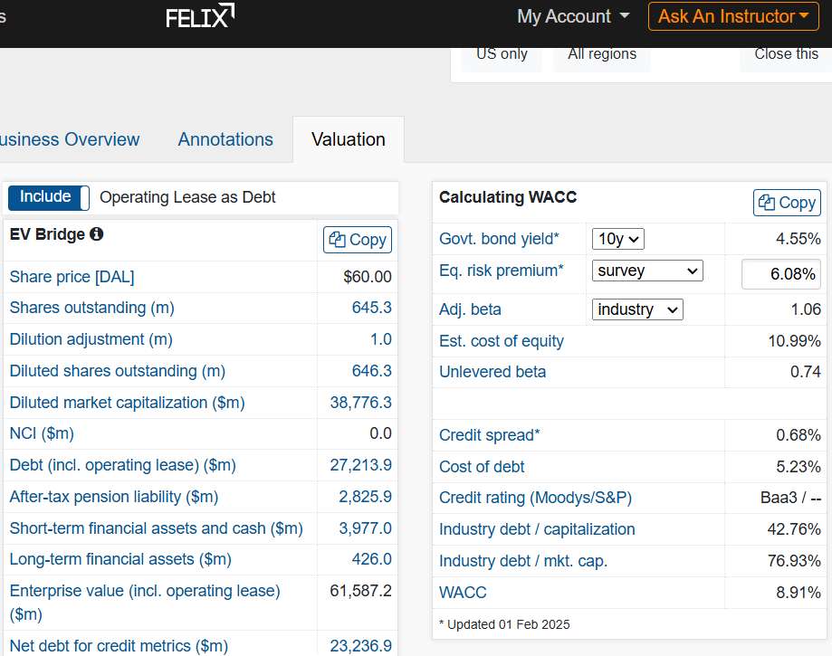

Notes on AI
For sake of completeness and to acknowledge the growing role of AI in the workforce we also asked popular generative AI models to address the question of airline WACC calculations, and to expand their answers with an explination of their assumptions.
Prompt: “Calculate the WACC of United Airlines and lay out assumptions for how you make the calculation”
ChatGPT 5.0: Relied on external website (gurufocus) with WACC calculations and assumptions, was unable directly explain their assumptions with any greater detail than can be found on their website. 9.2% WACC estimate, plausible range given at 7%-10%
Gemini 2.5 Flash: Sources of data not given without further prompting. Requesting the source of debt resulted in reference to 8k filings, but a new estimate of debt ($27.1B) significantly lower than the number used in WACC calculations ($32.31B). Difference appears to be exclusion of operating leases. 9.46% initial WACC estimate.
Claude Sonnet 4: Debt estimated significantly lower than other models ($27.1B), data not explicitly sourced but entire calculation referenced as being drawn from financial statements. 8.67% WACC estimate. Range given as 7.7%-9.32%.
As can be seen from the output above the models differ substantially both in clarity of assumptions used, and final estimates. Also of interest is the willingness of some models to propose a range of values they would consider reasonable with general assumptions (but not calculations) while some provide only a point estimate. Overall the finding is consistent with the survey of equity analysts, we have evidence of a divergence of opinion on the most appropriate method to calculate WACC even within a narrowly defined industry, which leads to uncertainty when using these estimates for further calculations such as firm valuation.

Conclusions
While the weighted average cost of capital (WACC) remains a cornerstone of valuation and capital structure analysis, its application in the airline industry is far from standardized. The treatment of short-term debt, cash, and especially operating leases creates significant variation in WACC estimates, with meaningful implications for firm valuation under the discounted cash flow approach. Our survey of equity research analysts confirms this lack of consensus: some practitioners view operating leases as debt equivalents, others treat them purely as expenses, and even among those who include them, the methods of valuation differ. Similarly, the choice between gross and net debt, or the use of balance sheet versus expense-based measures, produces divergent outcomes.
Data providers such as Bloomberg, FactSet, and Felix also reflect this inconsistency, each embedding different assumptions into their published estimates. For investors, managers, and students of finance, the key takeaway is that WACC is not a mechanical calculation but rather a judgment-laden exercise, particularly in industries with complex financing structures such as airlines. Analysts and decision makers must remain transparent about their assumptions, recognize the sensitivity of valuations to these inputs, and understand that small changes in WACC can drive large changes in estimated firm value.
Advances in financial technology and even AI-based modeling may help identify patterns across firms and provide more consistent benchmarks, but for now the estimation of WACC in the airline industry remains as much art as science.

References
Arditti, F. (1973) The Weighted Average Cost of Capital: Some Questions on its Definition, Interpretation, and Use, Journal of Finance, V 28.4 p1001-1007
Harris and Raviv (1991), The Theory of Capital Structure, Journal of Finance, V46.1 p297-355
Modigliani and Miller (1958). The cost of capital, corporation finance, and the theory of investment, American Economic Review 48, p261-297
Nantell, T. and Carlson, R. (1975) The Cost of Capital as a Weighted Average, Journal of Finance, V .30.5 P1343-1355
Solomon, Ezra (1955) Measuring a Company’s Cost of Capital, Journal of Business, V 28.4 p240-252

Appendix

Appendix 1: Survey Results

Question 1
When calculating WACC which of the following do you include as Debt? Please check all that apply.
Respondent | Notes Payable | ST Debt | Current LTD | LTD | Financial Leases | Operating Leases | Financial Derivatives
1 | X | X | X | X | X | X
2 | X | X | X | X
3 | X | X | X | X | X | X
4 | X | X | X | X | X | X
5 |  | X | X | X | X | X
6 | X | X | X | X | X | X | X
7 | X | X | X | X | X | X | X
Other items
Respondent 2 included unfunded pension Obligations
Respondent 3 included perpetual bonds

Question 2
If you include operating leases as debt, how are you valuing the operating leases?
Respondents 1, 3, 4, 5, 6: Balance sheet value of short term + long term operating leases
Respondent 7: multiple of operating lease expense, 7 * first year’s rent
Respondent 2 did not include operating leases from Q1

Question 3
When Calculating WACC how do you estimate the cost of debt?
Respondent 1, 4: Weighted average (based on debt value) of current YTM of outstanding bonds and/or estimated current cost of bank debt.
Respondent 3, 6: Simple average of current YTM of outstanding bonds and/or estimated current cost of bank debt.
Respondent 2: Long run financing rate based on default risk.
Respondent 5, 7: Declined to answer.

Question 4
When calculating the value of debt for a WACC calculation do you use the total debt or do you net cash and cash equivalents against the debt?
Respondent 1, 3, 4: Total Debt
Respondent 2, 7: Net debt = Debt less cash and cash equivalents
Respondent 6: Net debt – including restricted cash/deposits
Respondent 5: Declined to answer

Question 5
When Doing DCF do you
Respondent 1, 3, 6, 7: Add back the operating lease expense to find EBITDAR and then treat operating leases as debt equivalents
Respondent 2: Deduct Operating lease expense as an expense to get to EBIT
Respondent 3: Use NOPAT which is defined as pretax adjusted income for non-recurring items plus gross interest expense plus interest component of capitalized aircraft rent plus interest on pension
Respondent 5: Declined to answer.

